## **Principal’s welcome address**

Dear visitors,

On behalf of Sankt Georg Int. School, I am thrilled to welcome you to our website. Whether you are a prospective student, a parent, a community member, or simply someone interested in learning more about us, we are delighted you have taken the time to explore our site.

At Sankt Georg Int. School, we believe in providing an exceptional education that not only prepares our students for the future but also enriches their lives in the present. Our dedicated faculty and staff work tirelessly to create a learning environment that is engaging, challenging, and supportive, one that inspires our students to achieve their full potential.

We are committed to ensuring that every student who enters our doors feels valued, supported, and empowered to succeed. To us, education is not only about acquiring knowledge but also about developing the skills and character traits necessary to become responsible and contributing members of society.

As you navigate our website, I hope that you will gain a sense of the unique culture and community that we have built at Sankt Georg Int. School. From our academic programs to our extracurricular activities, we strive to provide our students with a well-rounded and enriching experience that prepares them for success in whatever path they choose.

Thank you for taking the time to visit our website. If you have any questions or would like to learn more about Sankt Georg Int. School, please do not hesitate to contact us. We would be honored to have the opportunity to share our story with you.

Sincerely,

Mrs. Angela Ezeuiro

Principal, Sankt Georg Int. Sch.

**PRIMARY SCHOOL**

At Sankt Georg Primary School, every child is valued and encouraged to reach their full potential. The school has a strong focus on personalized learning, with teachers working closely with students to identify their strengths and weaknesses and develop individualized learning plans. Students are also provided with a range of extracurricular activities, including sports, music, drama, and art, to explore their interests and talents.

The school's campus is an inviting and welcoming space that encourages students to learn, play, and explore. The classrooms are spacious and equipped with modern technology, providing an ideal learning environment for students. The school also has a well-stocked library, science labs, and computer rooms, allowing students to develop a well-rounded education.

Sankt Georg Primary School has a strong commitment to its community, with regular events and programs designed to foster a sense of belonging and collaboration among students, parents, and staff. The school's friendly and supportive atmosphere is reflected in its dedicated and passionate teachers, who go above and beyond to ensure that every child is supported and challenged to achieve their goals.

Overall, Sankt Georg Primary School is an exceptional institution that provides its students with a high-quality education, a stimulating learning environment, and a strong sense of community. It is a place where every child is valued and encouraged to reach their full potential, and where a love for learning is fostered and nurtured.

MATERIALS AND ACTIVITIES

**​**

The materials in our classroom are divided into five main areas. Activity with these materials involves physical and mental action, linking body and mind.

1. Practical life exercises: such as pouring, grating, polishing, sorting washing, buttoning, etc. Help the child learn to function in his environment and begin more advanced learning. The child develops attention to detail and a lengthened span of concentration through the successful completion of these basic exercises.
2. Sensorial activities: are designed to isolate and sharpen each of the five senses. Grading and comparing sounds, sizes, colors, textures, and shapes help organize the impressions a child receives.
3. Language Materials: are presented individually to take advantage of the most significant interest on the part of the child. Children are taught the sound and formation of the letters. Kinesthetically through the use of sand-paper letters and similar materials. Word-building activities of increasing difficulty are done over a long period of time.
4. Mathematical concepts: are presented through the extensive use of concrete materials. The child’s sensorial training enables him/her to identify and differentiate the idea of quantity built into the Montessori materials. The child gains the conception of numbers and their application in arithmetical operations.
5. Geography, social study, botany, zoology, science, music, and grammar are introduced through the use of concrete materials.

Enrichment activities are offered when available. In addition to activities involving the materials described above, the full Montessori day includes a lunch period, a listening period, a rest period, and individual and group activity periods. These include art and craft projects, special interest units, cooking, music, games, and outdoor activities. The children also enjoy field trips throughout the school year. Parents must sign a permission slip before any child is allowed to participate in a field trip.

ACADEMIC PROGRAMME

Education needs to be geared to meet the needs of the child. It is to be child-centered so as to promote not only cognitive, affective, and psychomotor domains of skills but also meant for physical, moral, language, social, and emotional aspects of the child’s life.  
Sankt Georg Primary School program, therefore, encompasses all Nigerian Primary Schools’ subjects including computer appreciation and application, French language, Moral instruction, and club activities.  
The school has since its inception grown in prominence by vision, quality of programs, and dove-tailed syllabus.

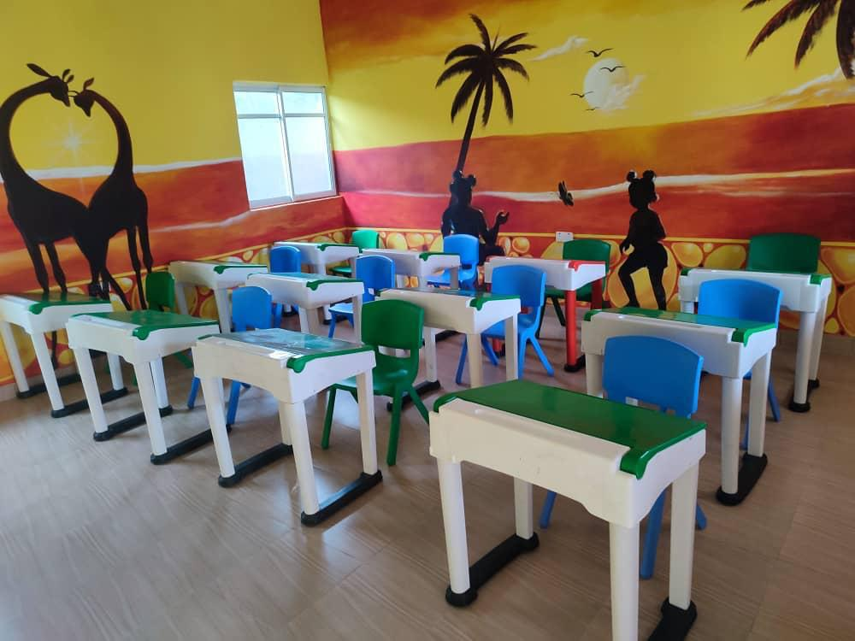

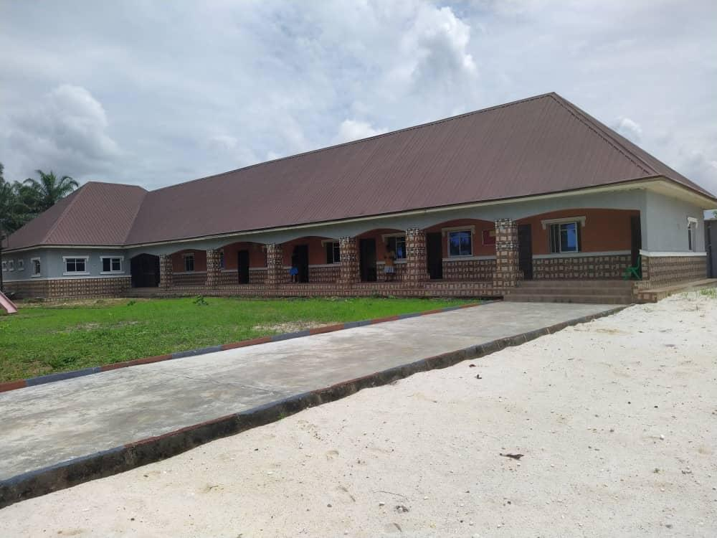

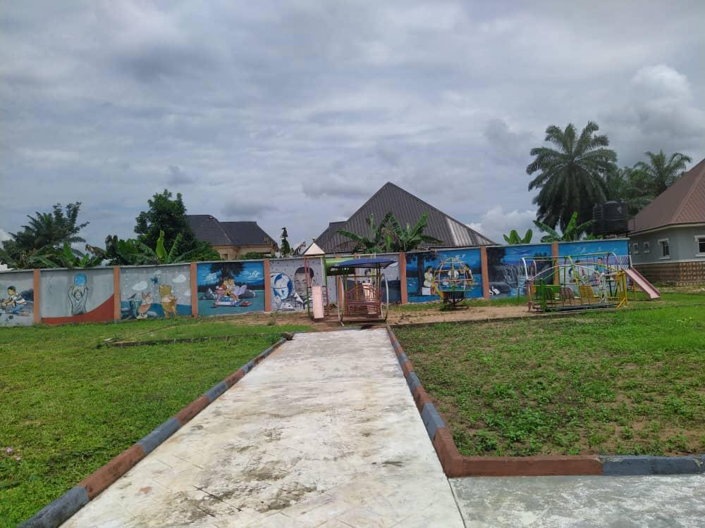

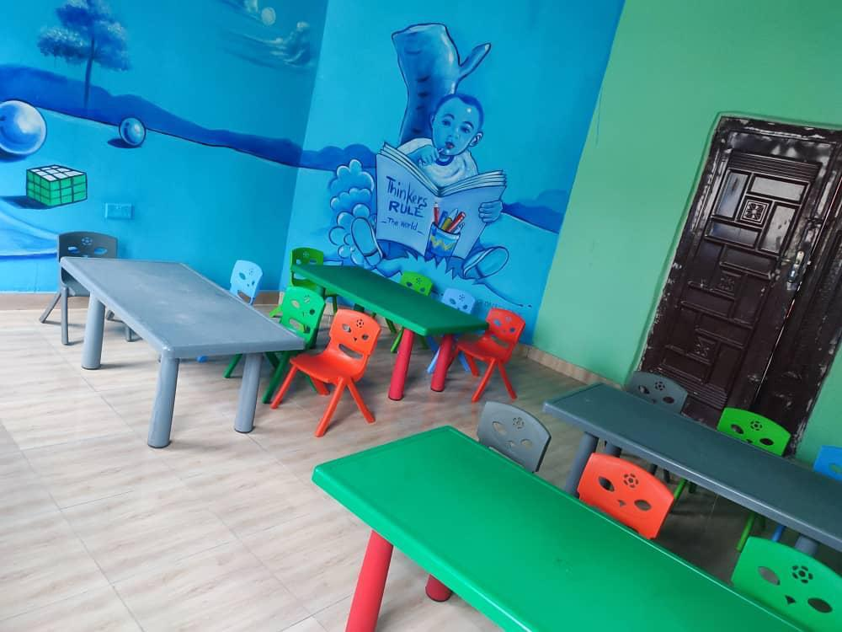

**ACADEMICS (SECONDARY)**

At Sankt Georg Secondary School, academic excellence is the top priority. The school offers a rigorous and comprehensive curriculum that challenges students to reach their full potential. The teachers are highly qualified and experienced, providing students with individualized attention and guidance that helps them to achieve their academic goals.

The school also offers various extracurricular activities, from sports to clubs and community service programs. These activities provide students with opportunities to develop their leadership skills, build friendships, and explore new interests. Many of these programs are led by passionate and knowledgeable teachers, who are committed to helping students grow and succeed in all aspects of their lives.

Another critical feature of Sankt Georg Secondary School is its modern facilities. The school's campus is spacious and well-equipped, with state-of-the-art classrooms, science labs, computer rooms, and sports facilities. These resources provide students with the tools they need to learn, explore, and excel in their academic and extracurricular pursuits.

Perhaps most importantly, Sankt Georg Secondary School has a strong culture of respect, inclusivity, and kindness. Students are encouraged to treat each other with empathy and understanding, and the school provides a safe and supportive environment for all students to learn and grow. This culture is fostered by the school's dedicated faculty and staff, who serve as role models for students and help to create a positive and welcoming school community.

In conclusion, Sankt Georg Secondary School is the best secondary school in town for a reason. With its exceptional academic programs, dedicated faculty and staff, modern facilities, and a strong culture of respect and inclusivity, this school provides students with a top-quality education and an exceptional learning experience. For parents and students looking for the best possible secondary education, Sankt Georg Secondary School is a clear choice.

​

The school curriculum is broad-based and is very much in line with the current national curriculum designed to meet the needs of the nation, particularly in the domains of modern science and technology.

﻿

The school has all it takes in terms of human and material resources and state-of-the-art facilities to provide first-class educational services to the students.

###### **CURRICULUM**

﻿  
The curriculum which usually answers the “WHAT” (do we teach) question of education comprises three parts, namely:  
a. The CORE Curriculum (which deals with examinable subjects)-i.e. the Cognitive Domain  
b. The CO-Curriculum (which deals with sports and games, labor, societies and clubs, and associations)-i.e. the Psychomotor Domain  
c. The HIDDEN Curriculum (which deals with attitudes and experiences that can be assimilated)-i.e. the Affective Domain

﻿

The perfect blending of these three parts of the curriculum at Sankt Georg International School produces self-confident, self-reliant students equipped to face daunting challenges. At the junior secondary school level, the students are exposed to all subjects in the curriculum in the first year but are allowed to make their own choices according to interest and academic ability in the senior secondary classes

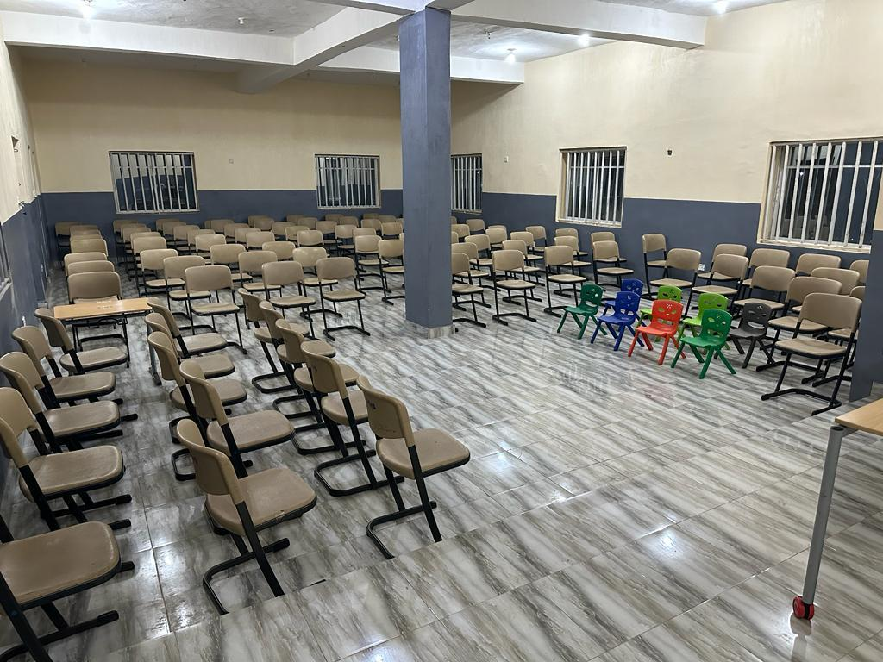

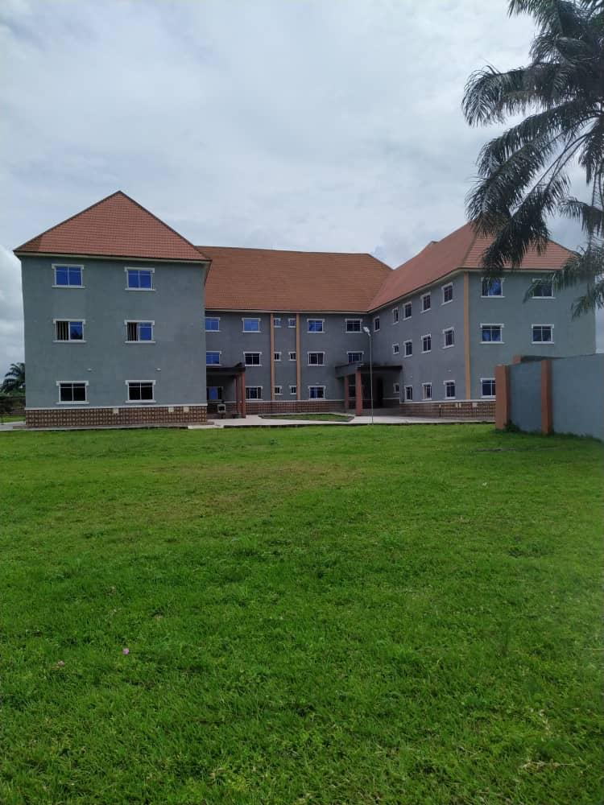

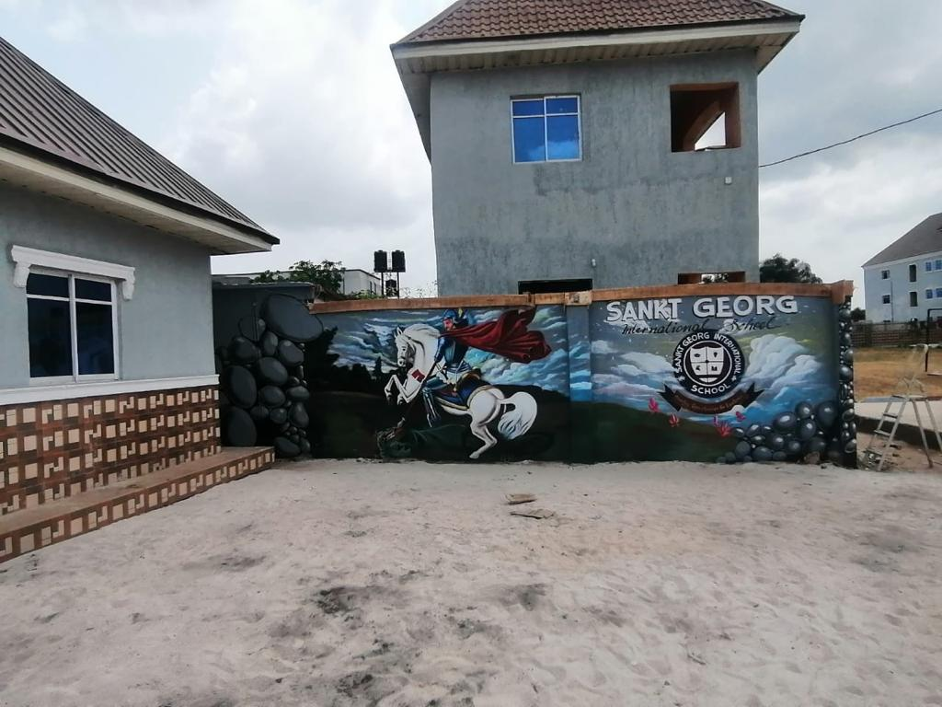

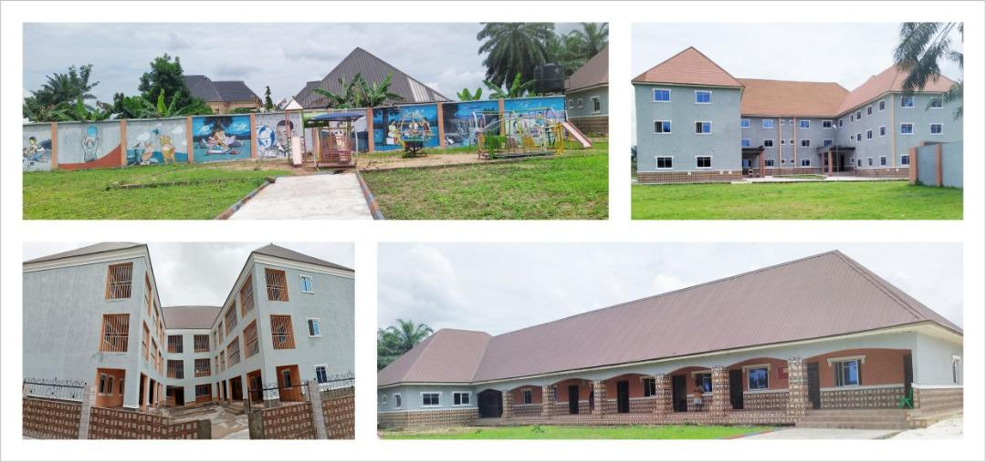

**WHAT OUR PARENTS SAY**

***MRS NWOKO CHINYERE***

*“My daughter went from struggling with Mathematics before I brought her here to winning ways*

*Today, she can confidently take part in Maths competitions at her level with a high chance of doing very well. Thanks to the transformation from members and staff of Sankt George.*

*Sankt George is the best place to be”*

***DR. MRS. EBE TOCHUKWU***

*“I got involved with Sankt George School after my son’s academic improvement after a few weeks of their free summer lesson. I had to pull him out of his previous school to continue at Sankt George. After the first term here, I’ve since more improvement both morally and academically.”*

***MRS LILIAN OGUOMA***

“My joy is the fact that after just one term, my daughter is now more outspoken, confident, and shows her eagerness to learn. It’s beautiful to watch as a parent.”

***DR OGUOMA OKECHUKWU***

*“Among other things, one area I love about the administration is how spontaneous they are with improvement in areas parents raise concerns.”*

**TEACHERS**

Mrs Onyenwe Josephine kelechi. HND Marketing.

*Head Teacher (Primary)*

